|  |  |
| --- | --- |
| Object Oriented Development Personal Application Proposal  Project Name: Text-Base Game  Brock Blazzard  11/25/20 |  |

# Description

This Application will work through a browser to have the user play a text-base game that will have progression and randomization. This game will also save player data to a database. The player will also load those save game states from the database.

# Diagram

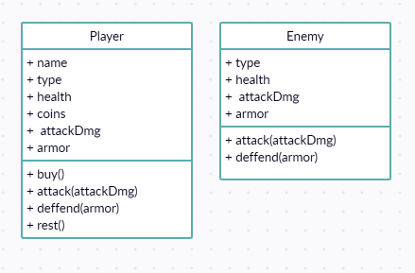

Player and Enemy Classes

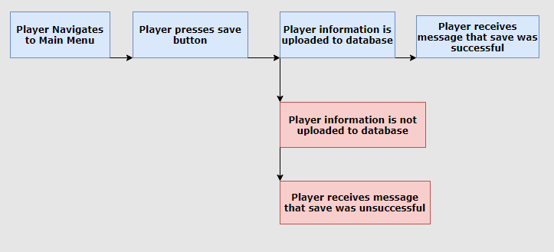

Saving a game state sequence diagram

# Topics incorporated into the application.

1. Exception Handling and Data Validation – verifying inputs and handling exception cause by those inputs
2. Hibernate – for loading and saving the player data
3. Servlets – A website for the player to play the game in.
4. Threads, Runnables, and Executors – a gameplay mechanic